**Assignment 10**

**Database Application Programming using JDBC**

**Softwares Used:**

* Front End - NetBeans 8.2 with JDK 8
* Back End – Oracle 11g
* For connection – OJDBC8 (Oracle Java DataBase Connectivity API v8)

**Screenshots of the Application’s Interface:**

**Main Menu:**

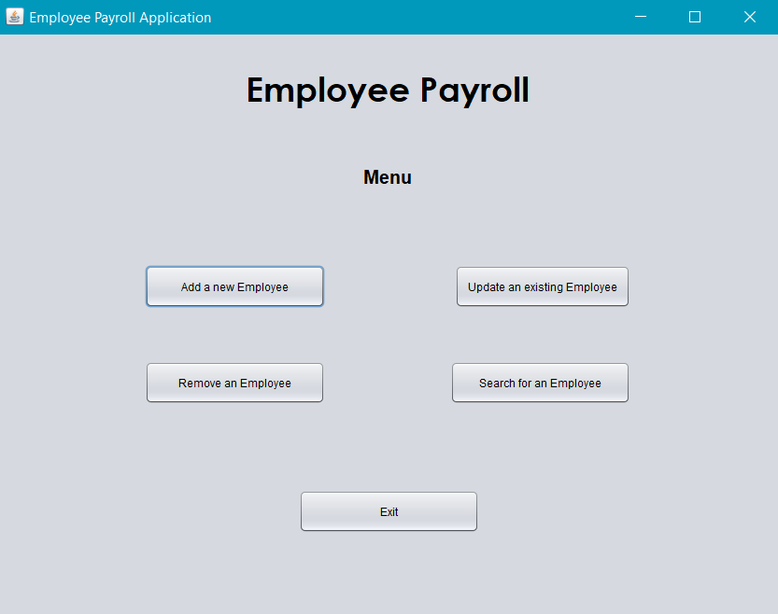

**Add Employee Window:**

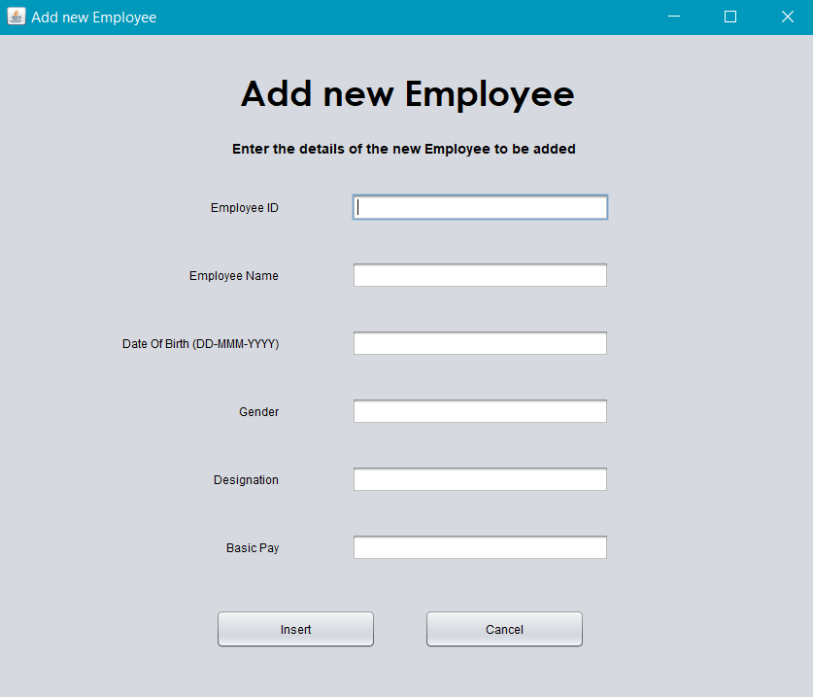

**After successful insertion:**

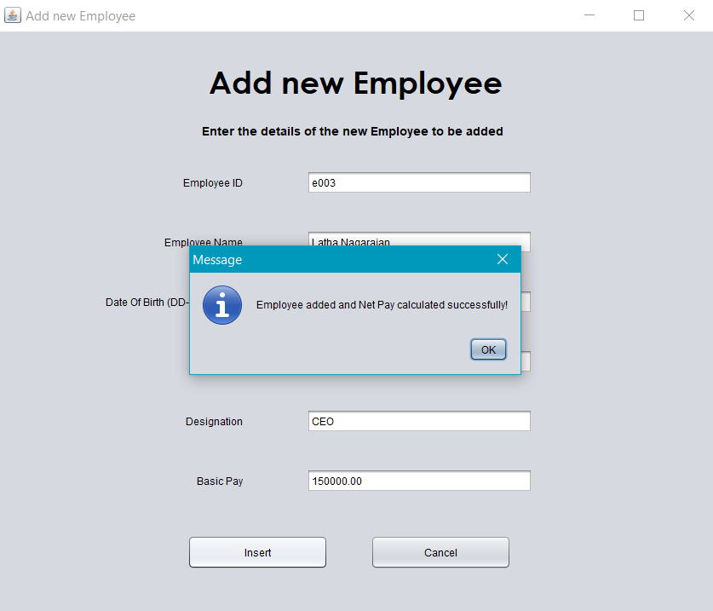

**Erroneous Insertion:**

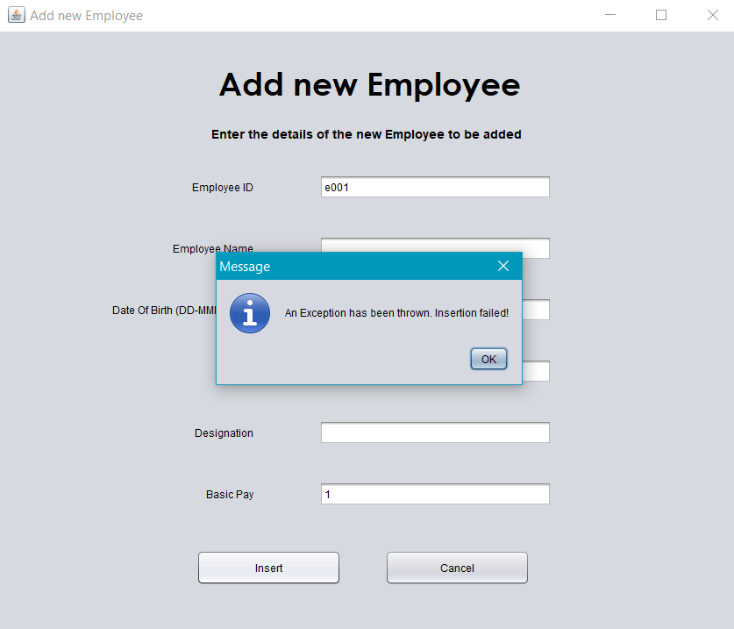

**Update Employee Window:**

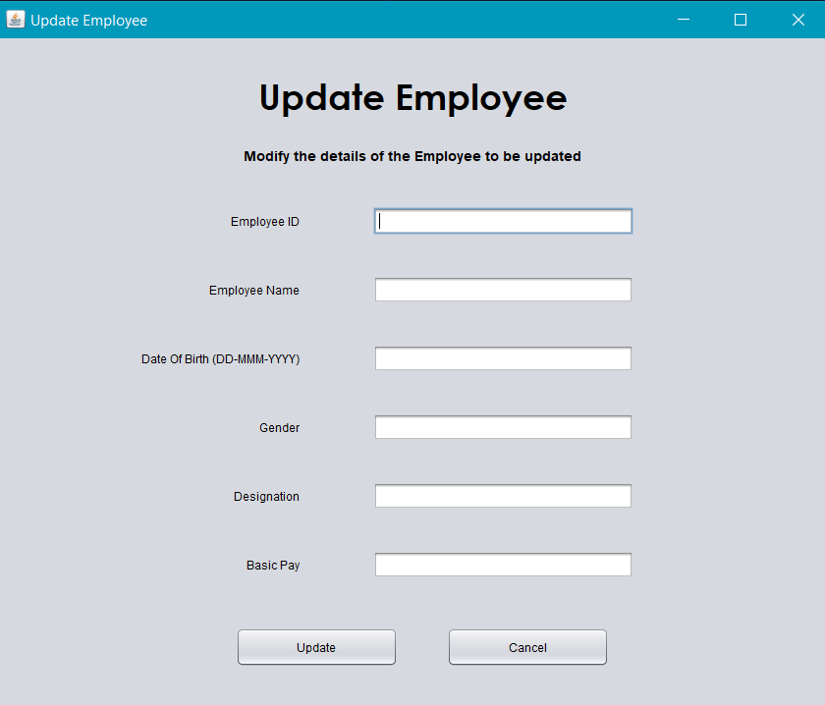

**After Successful updation:**

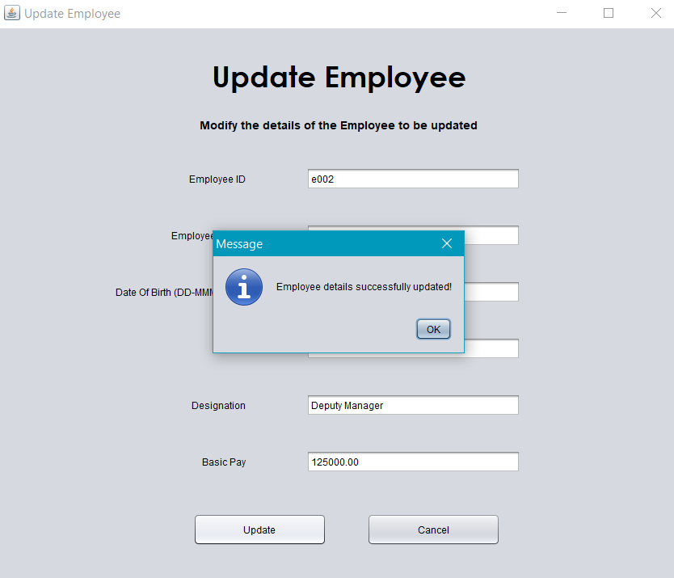

**Erroneous Updation:**

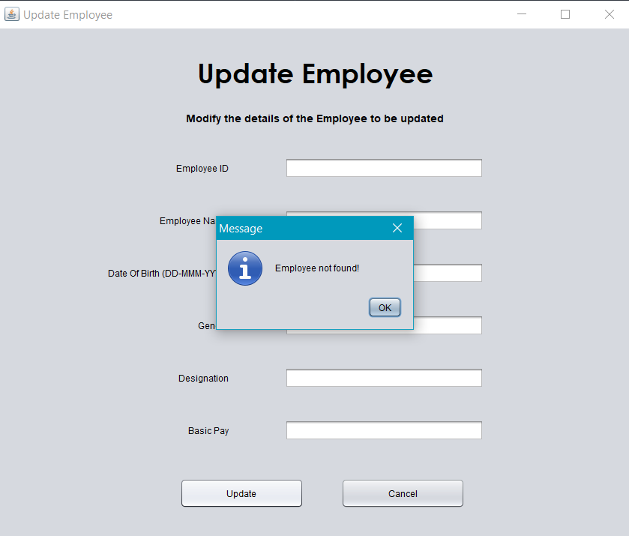

**Remove Employee Window:**

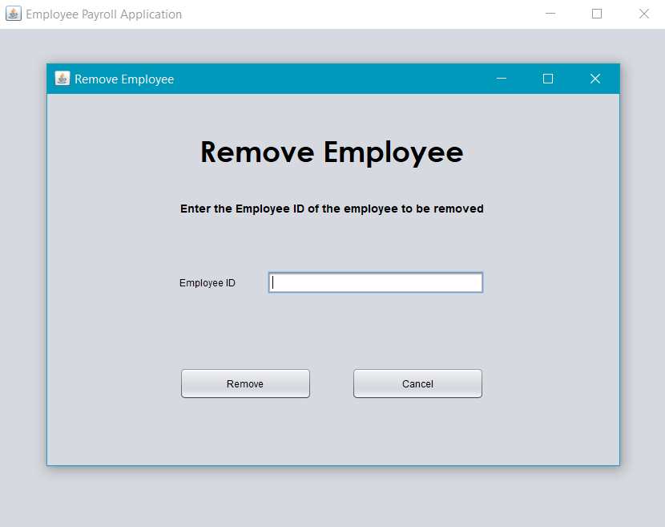

**After Successful Removal:**

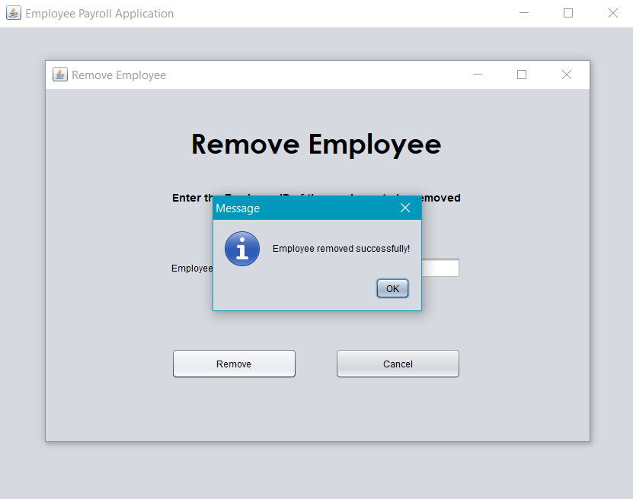

**Erroneous Removal:**

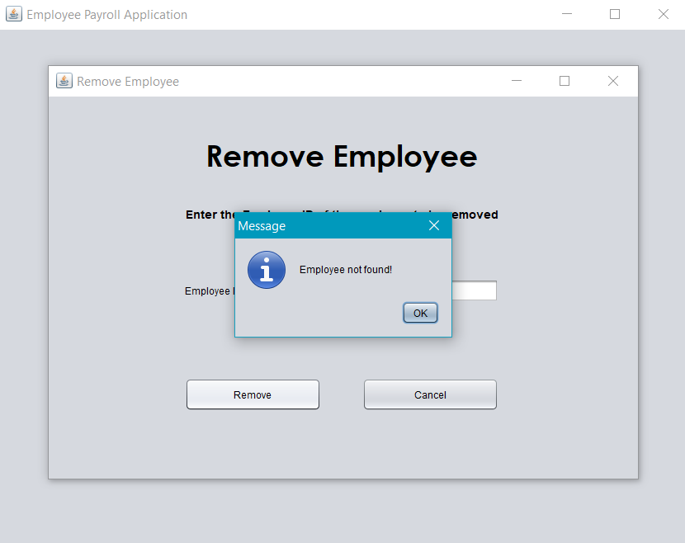

**Search Employee Window:**

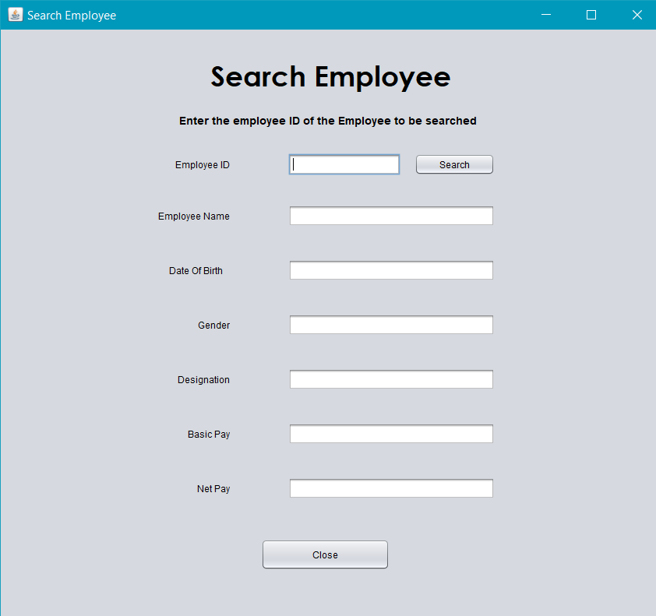

**After Successful Search:**

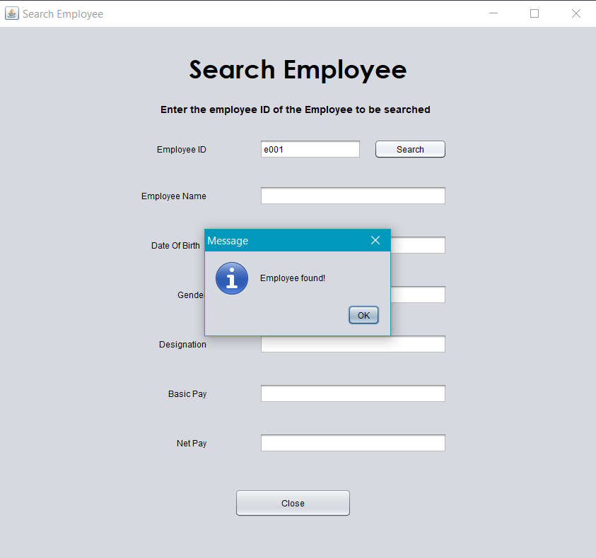

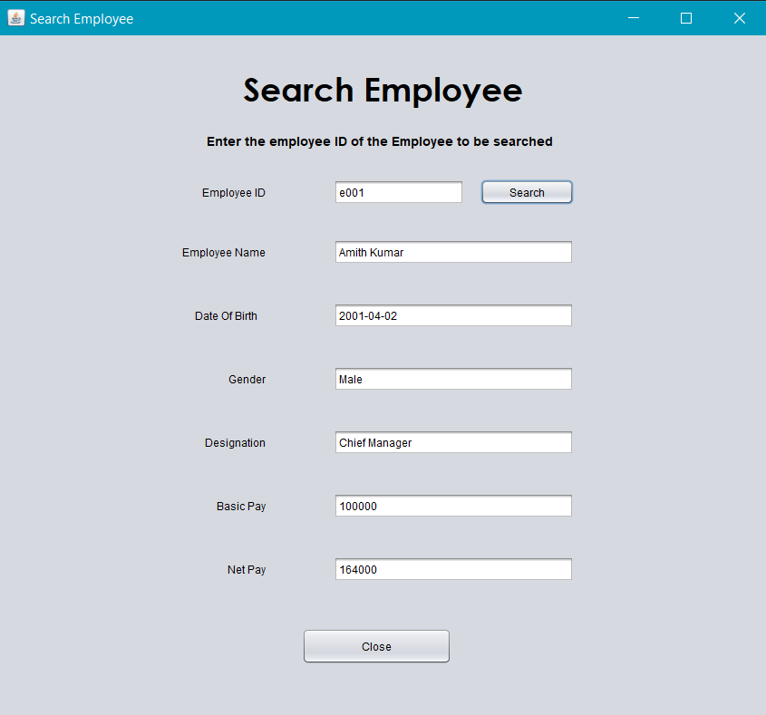

**Erroneous Search:**

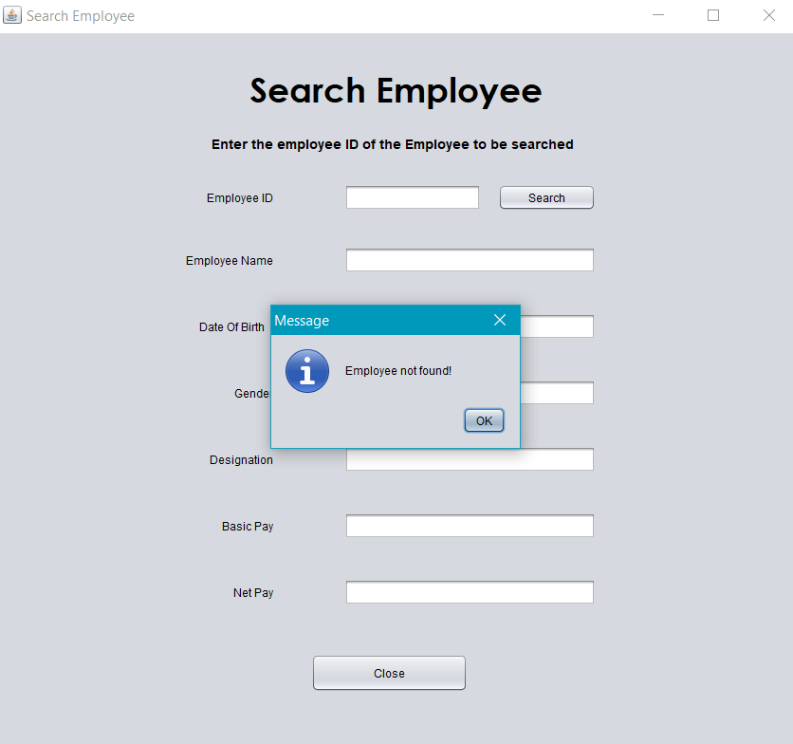

**SQL Script for table and procedure creation:**

create table emp_payroll

(

    eid varchar2(4) constraint EMP_PAYROLL_PK primary key,

    ename varchar2(30),

    dob date,

    sex varchar2(7),

    designation varchar2(30),

    basic number(9,2),

    da number(9,2),

    hra number(9,2),

    pf number(9,2),

    mc number(9,2),

    gross number(9,2),

    tot_deduc number(9,2),

    net_pay number(9,2)

);

create or replace procedure cal_net_pay

(p_eid emp_payroll.eid%type, p_basic emp_payroll.basic%type)

is

    p_da emp_payroll.da%type;

    p_hra emp_payroll.hra%type;

    p_pf emp_payroll.pf%type;

    p_mc emp_payroll.mc%type;

    p_gross emp_payroll.gross%type;

    p_tot_deduc emp_payroll.tot_deduc%type;

    p_net_pay emp_payroll.net_pay%type;

begin

    p_da:=0.6*p_basic;

    p_hra:=0.11*p_basic;

    p_pf:=0.04*p_basic;

    p_mc:=0.03*p_basic;

    p_gross:=p_basic+p_da+p_hra;

    p_tot_deduc:=p_pf+p_mc;

    p_net_pay:=p_gross-p_tot_deduc;

    update emp_payroll set da = p_da, hra = p_hra, pf = p_pf, mc = p_mc, gross = p_gross, tot_deduc = p_tot_deduc, net_pay = p_net_pay

    where eid = p_eid;

end;

/

**Screenshots of the Emp_Payroll table updating in real time:**

